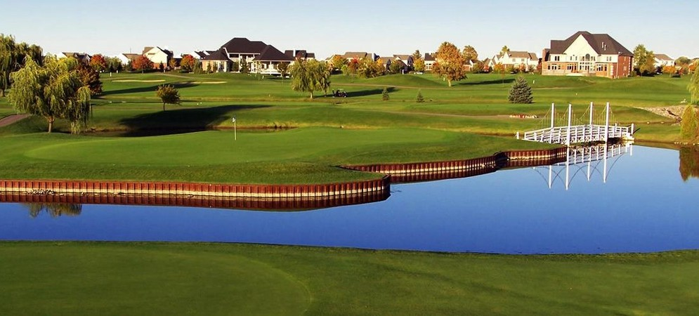
Variable Pricing

Tanglewood Golf Club utilizes variable pricing for all tee times.

What is Variable Pricing?

By definition, variable means, “able to be changed or adapted.” At Tanglewood Golf Club we view variable as the new standard. Our golf rates are adjusted in real-time, based on several factors, which include, availability, demand and even weather.

While this pricing strategy may be new to golf, many other industries such as airlines, hotels, and event tickets have been using this pricing strategy for years. Our Variable Pricing structure now allows you, the golfer, to find the rate you want.

Book online at tanglewoodlion.com

Variable Pricing

This pricing model, called variable pricing, is likened to what the airline, travel, sporting events, hospitality, and yes, even golf industries have been using. here prices fluctuate based on elements that impact demand.

How will variable pricing work?
Prices will be determined based on historical data that considers the day of the week. time of day, season, weather, and occupancy (or how busy the golf course is during that time of the day. The key takeaway is prices will be daily with the customer choosing either the time of day they wish to play regardless of the rate or the rate they prefer to pay depending on the time.

How much will green fees go up?
Green fee pricing will fluctuate from $1 to $20 above the posted rate for all player types based on the demand and all the other contributing factors that define that day slot. We will continuously monitor and reevaluate the variable pricing model throughout the year.

Could green fees be lower?
Yes, if these same measures show demand to be low during any given time slot, prices can fluctuate down as well.

Would green fees have gone up without dynamic pricing?
Yes, instead of an arbitrarily increasing all prices by a fixed amount, variable pricing will offer a range based on demand between 3% to 20% depending again on day of week. time of day, and player type.

Book online at tanglewoodlion.com

